Dear Parents and Carers,
Welcome to Year 4! I’m Miss Ainsworth, and I’m absolutely delighted to be your child’s class teacher this year. Supporting our class is the lovely Mrs Fish, who some of you may remember as Miss Hull.

We are both really excited for the year ahead and can’t wait to get to know you and your children. Year 4 is a fantastic time for developing independence, growing in confidence, and tackling exciting new learning — and we’re here to support every step of the journey.
Over the next few weeks, as the children settle into their new routines, we’ll be holding a parent meeting so we can meet properly and I can share more about the year ahead. The date and time for this will be posted soon on Class Dojo, so please keep an eye out.
Here are a few important things to know as we begin.

Reading
Each child will receive a reading book and a reading diary. These should be kept in their school bag every day, as they will read with Mrs Fish once a week.
As part of their homework, children should aim to read at least three times a week at home. Little and often makes a big difference to both fluency and confidence.

Homework
Homework will be set every Friday, usually as an online task. If your child has trouble accessing the internet or an electronic device at home, please let me know — we’ll make sure there’s an alternative in place.

Times Tables
A key focus this year is times tables. In June, all Year 4 pupils across the country take part in the Multiplication Tables Check — a national assessment designed to test rapid recall of times tables up to 12 x 12. We’ll be practising regularly in school, and your support with regular practice at home will be hugely beneficial.

I want you to know that I am here to support both you and your child throughout the year. I aim to be approachable, kind, and consistent — and always open to working together. If you ever have any questions, concerns or would just like a quick chat, please do come and speak to me at the end of the school day (mornings tend to be quite busy). You can also message me on Class Dojo, which I check regularly.
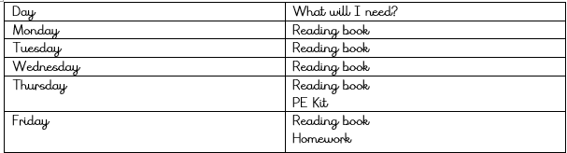
Here’s to a brilliant year ahead. I’m really looking forward to all that we’ll achieve together!

Warm wishes,
Miss Ainsworth

