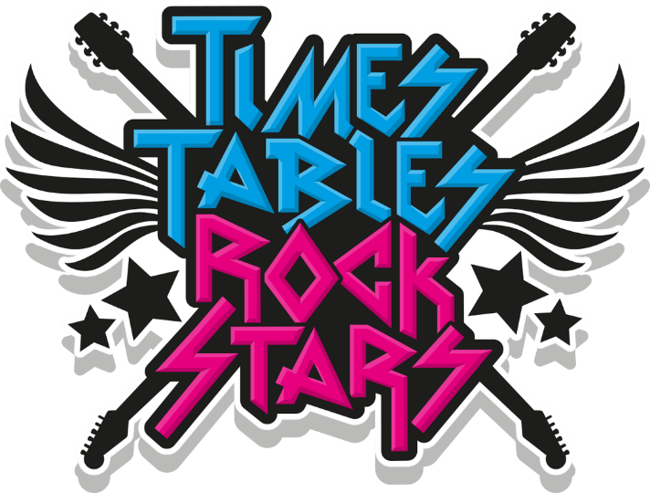
Times Table Rock Stars is a fun and challenging programme designed to help pupils master the times tables.

Game:
Garage – This is the main mode the children should play. The questions will only come from the times tables the teacher has set. As pupils start to answer questions, TT Rock Stars works out which facts they take longer on and will give them more of these questions to answer.

To log into Times Table Rock star, go to https://ttrockstars.com/ and put in the school name, with your username and password. You can also download the app for free on your phone or IPad. https://ttrockstars.com/
If you have forgotten your login details, please let me know and I’ll remind you.

