Multiplication Check
The Multiplication Tables Check is a short online test taken by Year 4 pupils in England.
- It checks how well children know their times tables up to 12 × 12.
- Pupils answer 25 multiplication questions on a computer or tablet.
- They have 6 seconds to answer each question.
Here are ways you can help your child:
Picture | Game | Link
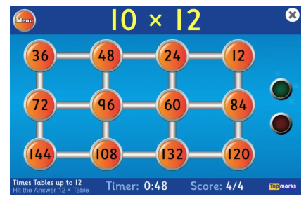 | Hit the Button | https://www.topmarks.co.uk/maths-games/hit-the-button | This game is great for practising speed skills. As the check is under 6 seconds this is great practice recalling times tables at a fast pace.
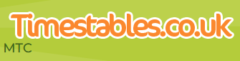 | Multiplication Check | https://www.timestables.co.uk/multiplication-tables-check/ | This game is a replica of the real check, it is set out in the same way. This is great for children nervous about the check or for children to get an idea of what score they can achieve currently.
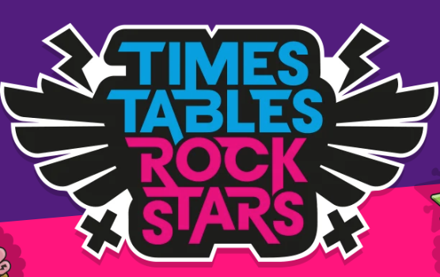 | Times Table Rockstar. | https://ttrockstars.com/ | Rockstars is great for reluctant children, as this is in a game format children may be more inclined to play. Using garage mode gives children the times table facts that they struggle with, helping them improve.
The most effective way for children to practise is “little and often.” Short, regular practice sessions help skills stick in long-term memory. When children practise for just a few minutes several times a week, their brains have time to process and strengthen what they’ve learned.
In contrast, practising once a week for a long period can be tiring and overwhelming. Children are more likely to lose focus and forget parts of what they practised.
A good rule of thumb is several short sessions during the week. This keeps practice positive, manageable, and much more effective for building confidence and progress.

